IN THE COUNTY COURT OF THE NINTH JUDICIAL CIRCUIT IN AND FOR ORANGE COUNTY, FLORIDA

|  |  |
| --- | --- |
| <<PROVIDER_SUITNAME>>,  a/a/o <<INJUREDPARTY_NAME>>  Plaitniff  vs.  <<INSURANCECOMPANY_SUITNAME>>  Defendant | Case No.: <<INDEXORAAA_NUMBER>>  **NOTICE TO APPEAR FOR**  **PRETRIAL CONFERENCE/MEDIATION** |
|  |  |

STATE OF FLORIDA -NOTICE TO PLAINTIFF (S) AND DEFENDANT (S)

YOU ARE HEREBY NOTIFIED that this case may be eligible to participate in Online Dispute Resolution as a way to resolve this matter. Should you wish to participate you ***must*** have an email address on file with the Clerk of Court. Email: [ODR@ocnjcc.org](mailto:ODR@ocnjcc.org), no later than 14 days prior to the in-person Pre-Trial Conference for instructions.

# IF YOU DO NOT PARTICIPATE IN ONLINE DISPUTE RESOLUTION OR YOU DO

***NOT COME TO A FINAL RESOLUTION,*** you are required to appear in person or with an attorney VIA MICROSOFT TEAMS via the phone number below on at

for a PRETRIAL CONFERENCE.

# MICROSOFT TEAMS INFORMATION

[***https://tinyurl.com/y6j3n4af***](https://tinyurl.com/y6j3n4af) ***Call: 321-430-3303***

# Conference ID 318 593 134#

## IMPORTANT- READ CAREFULLY

**THE CASE WILL NOT BE TRIED AT THE PRETRIAL CONFERENCE BUT MAY BE MEDIATED AT THAT TIME.**

## DO NOT BRING WITNESSES. YOU MUST APPEAR IN PERSON OR BY AN ATTORNEY.

***The defendant(s) must participate in Online Dispute Resolution Program OR appear in court on the date specified in order to avoid a default judgment.*** The Plaintiff(s) must participate ***in Online Dispute Resolution Program OR appear in court on the date specified*** in order to avoid having the case dismissed for lack of prosecution. A written MOTION or ANSWER to the court by the plaintiff(s) or defendant(s) shall not excuse the personal appearance of a party or its attorney in the PRETRIAL CONFERENCE/MEDIATION. The date and time of the pretrial conference CANNOT be rescheduled without good cause and prior court approval.

Any business entity recognized under Florida law may be represented at any stage of the trial court proceedings by any principal of the business entity who has legal authority to bind the business entity or any employee authorized in writing by a principal of the business entity. A principal is defined as being an officer, member, managing member, or partner of the business entity. Written authorization must be brought to the Pretrial Conference.

The purpose of the pretrial conference is to record your appearance, to determine if you admit all or part of the claim, to enable the court to determine the nature of the case, and to set the case for trial if the case cannot be resolved at the pretrial conference. You or your attorney should be prepared to confer with the court and to explain briefly the nature of your dispute, state what efforts have been made to settle the dispute, exhibit any documents necessary to prove the case, state the names and addresses of your witnesses, stipulate to the facts that will require no proof and will expedite the trial, and estimate how long it will take to try the case.

Mediation may take place at the pretrial conference. Whoever appears for a party must have full authority to settle. Failure to have full authority to settle at this pretrial conference may result in the imposition of costs and attorney fees incurred by the opposing party.

If you admit the claim, but desire additional time to pay, you must come and state the circumstances to the court. The court may or may not approve a payment plan and withhold judgment or execution or levy.

**RIGHT TO VENUE**: The law gives the person or company who has sued you the right to file suit in any one of several places as listed below. However, if you have been sued in any place other than one of these places, you, as the defendant(s), have the right to request that the case be moved to a proper location or venue. A proper location or venue may be one of the following:

1. Where the contract was entered into;
2. If the suit is on unsecured promissory note, where the note is signed or where the maker resides;
3. If the suit is to recover property or to foreclose a lien, where the property is located;
4. Where the event giving rise to the suit occurred;
5. Where any one or more of the defendant(s) sued resides;
6. Any location agreed to in a contract;
7. In an action for money due, if there is no agreement as to where suit may be filed, where payment is to be made.

If you, as the defendant(s), believe the plaintiff(s) has/have not sued in one of these correct places, you must appear on your court date and orally request a transfer, or you may file a WRITTEN request for transfer, in affidavit form (sworn to under oath) with the court 7 days prior to your first court date and send a copy to the plaintiff(s) or the plaintiff(s) attorney, if any.

A copy of the Statement of Claim shall be served with this summons.

Dated: 11/24/20

iffany Moore Russell Clerk of the Court

By:

Deputy Clerk

(SEAL)

**REQUESTS FOR ACCOMMODATIONS BY PERSONS WITH DISABILITIES**

**If you are a person with a disability who needs any accommodation in order to participate in this proceeding, you are entitled, at no cost to you, to the provision of certain assistance. Please contact the ADA Coordinator, Human Resources, Orange County Courthouse, 425 N. Orange Avenue, Suite 510, Orlando, Florida, (407) 836-2303, at least 7 days before your scheduled court appearance, or immediately upon receiving this notification if the time before the scheduled appearance is less than 7 days; if you are hearing or voice impaired, call 711.**

**Form 7.321 Notice to Appear for Pretrial Conference/Mediation Rev. 06/18/2010**

ADMTNISTRATIVE ORDER NO. 2009-12-02

TN TH E C IRC UIT COURT OF THE NINTH JUDICIAL CIRCUIT, IN AND FOR ORANGE COUNTY, FLORIDA

**AMENDED ADMINISTRATIVE ORDER GOVERNING FIRST PARTY INSURANCE CLAIMS CASES**

**WHEREAS,** pursuant to Article V, section 2(d) of the Florida Constitution and section

43.26 , Florida Statutes, the Chief Judge of each judicial circuit is charged with the authority and the power to do everything necessar y to promote the prompt and efficient administration of justice ; and

**WHEREAS,** pursuant to the Chief Judge' s constitutional and statutory responsibility for administrative supervision of the courts within the circuit and considering available resources, to create and maintain an organization capable of effecting the efficient, prompt, and proper administration of justice for the citizens of this State, the Chief Judge is required to exercise direction, *see* Fla. R. Jud. Admin. 2.215(b)(2 ), (b)(3); and

**WHEREAS,** it has been officially made known to me that it is nece ssa ry to the dispatch of business of the Orange County Court, Ninth Judicial Circuit, Florida, that the Court efficiently utilize the services of the Clerk of the Court, the services of the Court's mediation services, and that the Court refrain from issuing duplicate orders in each applicable individual court case; and

**WHEREAS,** certain cases are routinely filed within the Small Claims Division of the Orange County Civil Court, to wit: claims by insureds (or assignees of insureds) against insurer s for ins urance policy benefits, such as Personal Injury Protection benefits, automobile windshield glass benefits and other property insurance benefits (" First Party Insurance Claim s"). In 2019, more than 25,000 First Party Insurance Claims cases were filed in the Small Claims Divis ion in Orange County; and,

**WHEREAS,** the filing of such cases in the Small Claims Division results in issuance in each case of a Summons/Notice to Appear pursuant to Rule 7.090, Florida Small Claim s Rules, setting a pretrial conference within 50 days from the date of filing of the action and, in the Ninth Judicial Circuit, setting a mediation conference with the Court ' s mediation services; and

**WHEREAS,** the parties in such First Party Insurance Claims are represented by counsel, the parties typically seek extensive discovery, and, as a result, the trial courts routinely invoke the Florida Rules of Civil Procedure as permitted by Rule 7.020(c), Florida Small Claims Rules, resulting in the entry of individual orde rs in ea ch case; and

**WHEREAS,** the invocation of the Florida Rules of Civil Procedure uniformly at inception of the case throughout Orange County in First Party Insurance Claims cases promotes judicial economy and efficiency, and avoids unnecessary cons umption of pretrial and mediation schedule and other resources;

**NOW, THEREFORE, I,** Donald A. Myers, Jr., m order to facilitate the efficient

operation of the administration of justice, and pursuant to the authority vested in me as Chief Judge of the Ninth Judicial Circuit of Florida under Florida Rule of Judicial Administration 2.215, hereby order that, **effective immediately** unless otherwise provided herein, to continue until further order, and superseding any provisions in prior Administrative Orders which may be inconsistent, the following provisions apply to all First Party Insurance Claims cases:

1. **Florida Rules of Civil Procedure Apply:** The Florid a Rules of Civil Procedure are hereby invoked at the time of filing the case for all First Party Insurance Claims cases filed in the Small Claims Division of the Orange County Court. (This is a restatement and clarification of the invocation of the Florida Rules of Civil Procedure at the inception of the case contained in Administrative Order 2009-12-01.)
2. **Civil Cover Sheet Addendum:** Effective immediately, for all First Party Insurance Claims cases, the plaintiff must file a complaint that specifically states the Ninth Judicial Circuit Court Administrative Order 2009-12-02 applies. A Civil Cover Sheet County Court Addend um, in the form attached hereto as Exhibit "A," shall be filed together with the Complaint.
3. **Summons:** In all First Party Insurance Claims cases appropriately designated under paragraph 2 above, the clerk shall issue a summons consistent with the Florida Rules of Civil Procedure. The Clerk shall not set a small claims pretrial conference or small claims mediation in the case.
4. The provisions of this Administrative Order may be modified by the trial court in any individual First Party Insurance Claim s case.
5. Administrative Order 2009-12-01 is vacated and set aside except to the extent that it has been incorporated and/or amended herein. Vacating an Administrative Order that vacates a prior Order does not revive the prior Order.

**DONE AND ORDERED** at Orlando, Florida, *this* ***8*** day of September, 2020.

Copies to:

Clerk of Courts, Orange County Clerk of Courts, Osceola County General E-Mail Distribution List [http:// www.ninthcircuit.org](http://www.ninthcircuit.org/)

Page 2 of 4

**EXHIBIT ''A''**

[CIVIL COVER SHEET COUNTY COURT ADDENDUM]

Page 3 of 4

CIVIL COVER SHEET COUNTY COURT ADDENDUM

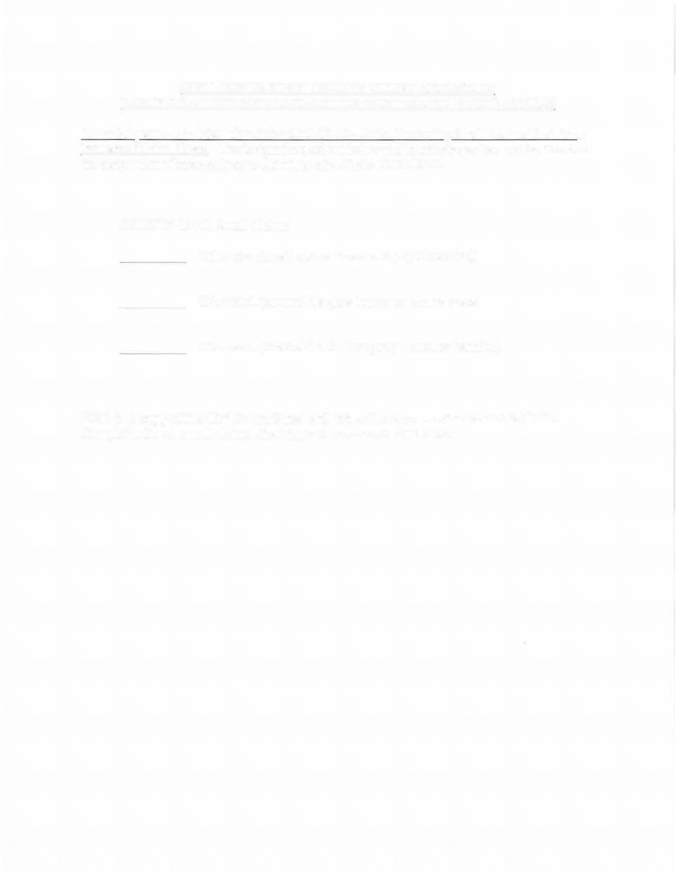

PARTY OR ATTORNEY FILING ACTION MUST SELECT WHICH APPLIES

Cases Subject to Administrative Order 2009-12-02 - Order Governing Small Claims First Party Insurance Claims Cases. The designations set out below shall guide the parties and the Court in the assignment of cases subject to Administrative Order 2009-12-02.

COUNTY CIVIL Small Claims

Other civil (small claims Personal Injury Protection)

Other civil (automobile glass insurance claims cases)

Other civil (other claim for first party insurance benefits)

***NOTE:* A copy of the Civil Cover Sheet and this Addendum must be served with the Complaint for all small claims First Party Insurance Claims cases.**